[**salon**](https://www.salon.com/2024/08/23/kamala-harris-practices-the-post-racial-weve-been-waiting-for/) **COMMENTARY**

[**Kamala Harris practices the post-racial politics we’ve been waiting for | Salon.com**](https://www.salon.com/2024/08/23/kamala-harris-practices-the-post-racial-weve-been-waiting-for/)

**Kamala Harris practices the post-racial politics we’ve been waiting for**

**Harris/Walz may rescue diversity from "Diversity, Equity, and Inclusion" protocols**

**By**[**Jim Sleeper**](https://www.salon.com/writer/jim_sleeper)**August 23, 2024 5:31AM (EDT)**

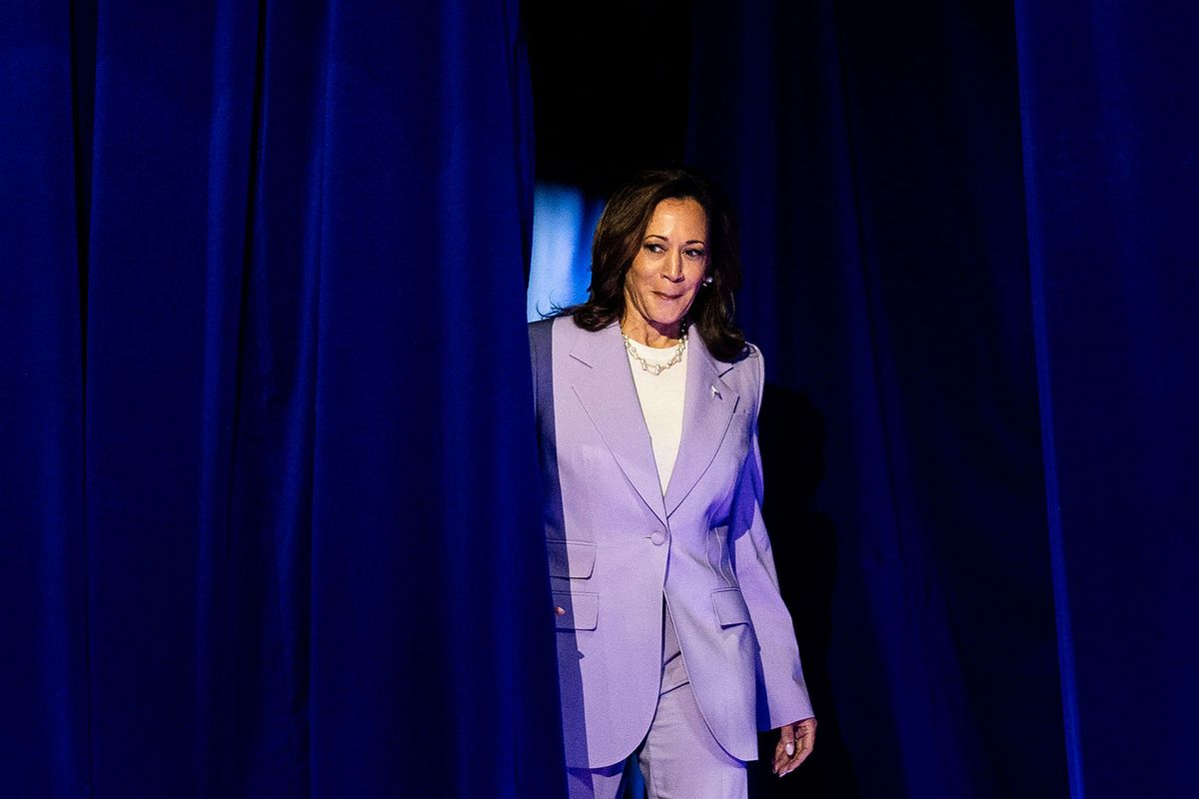**On the U.S. Presidential campaign trail stopping in battleground states, Vice President Kamala Harris and her running mate Minnesota Gov. Tim Walz speak in Las Vegas, Nevada on Saturday August 10, 2024. (Melina Mara/The Washington Post via Getty Images)**

Like some other liberal Democrats who resisted warnings in July that President Biden should end his re-election bid, [I pushed back](https://theberkshireedge.com/whose-decline-is-more-severe-joe-bidens-or-the-news-medias/) against the "It's time to go, Joe" messages that were coming from news stories and commentaries. If Biden could make it through re-election in November, I thought, he wouldn’t need to barnstorm the country again; he could continue working from the Oval Office to advance the experienced, wise decision-making that he’d delivered since 2021 (with a notable exception in the Middle East).

Even when he stepped down and endorsed Kamala Harris to succeed him, I wondered if his vice president was seasoned and wise enough to continue his best work. Brilliant campaigning isn’t the same as governing, and a disturbingly large swath of the electorate that’s racially obtuse and/or misogynous won’t vote for her, even though some of its members did vote for an African-American male in 2008 in the wake of the Bush administration’s Iraq War fiasco, emergency-management failures in Hurricane Katrina, and the financial meltdown of 2008 — the latter in complicity with neoliberal Democrats who thought that breaking glass ceilings excuses their breaking up the Glass-Steagall law of 1933, whose repeal Bill Clinton signed in 1999, thereby enabling the plunge into wild financing that helped bring on the meltdown.

Would a President Harris really continue Joe Biden’s efforts to build back better? Her initiatives as vice president have been muted, even mooted. Even now, we need to be sure of her professed commitment to strengthen the legal and economic foundations of working- and middle-class security and comity.

Fortunately, though, one of Harris' first truly independent, consequential decisions about governing – making Minnesota Gov. Tim Walz her running mate – promises to rescue diversity at its best from elitist and progressive “diversity, equity, and inclusion" measures that sometimes mire every ethno-racial group in its place with a label on its face. "We have so much more in common than what separates us," she said in her nomination acceptance speech last night.

Her own family background and marriage have shown that true diversity can't be pre-scripted and bureaucratically mandated. It's a consequence of fair laws and practices that aren’t “of color” or “white” and that does notmake your racial physiognomy or surname a signal that you're the bearer of “culture” which you may not actually identify with. Such cookie-cutter “diversity” reinforces the opposite of civic vibrancy and individual freedom. It depicts your citizenship and even your personhood ethno-racially whenever you walk for the first time into a classroom, workplace, or courtroom.

That kind of ‘diversity doesn't curb racist discrimination as often as it recapitulates it.  Its torturous racial etiquette often prompts epithets as surely as hypocrisy prompts hostility. And it distorts sincere efforts to re-focus our race lenses against pious conservative pretension to color blindness that conceals monstrous injustices.

I’ve made such arguments in many ways, including [here in Salon](https://www.salon.com/2017/09/02/trump-is-bent-on-becoming-a-tyrant-and-liberals-have-never-been-more-helpless-to-stop-him_partner/) and morecomprehensively in my book "[Liberal Racism](https://www.jimsleeper.com/?attachment_id=4532)" (whose opening chapter, "Life After Diversity," I urge you to click on and read). This year, the Massachusetts Institute of Technology became the first elite university to stop requiring job applicants to submit statements indicating how they would enhance diversity. M.I.T., whose percentage of Black students enrolled in last year’s incoming freshman class [dropped to 5 percent from 15 percent](https://www.nytimes.com/2024/08/21/us/mit-black-latino-enrollment-affirmative-action.html) the year before the Supreme Court’s decision banning affirmative action, isn't saying that diversity is bad; it's saying, in effect, that commitments to advance it can't be prescribed and imposed as they've been by "Diversity, Equity, and Exclusion" protocols.

Harris’ own blended ethno-racial background of Jamaican and Indian ancestries was a consequence of her parents' freedom. It confounds the simplistic color coding and racial mind games that are played by people like someone I'll nickname as "Donnie 'Bone Spurs' Trumpf." Harris chose, freely, the historically Black Howard University as her college, and she honors the African American identity that Obama, [whose parentage was racially mixed, too](https://www.dissentmagazine.org/online_articles/things-no-one-talks-about/),embraced and internalized, but she rightly looks beyond racial identification as a presidential candidate.

Tim Walz, far from representing the toxic “white male” who haunts too many progressive imaginations and pronouncements, is one of the truly countless white men who’ve built bridges to transracial justice. Those bridges may not be quite what Pennsylvania Gov. Josh Shapiro had in mind when he said, about Walz, “Everybody in America knows, when you need a bridge fix, call that guy,” but the metaphor carries Walz’s "can-do" and social-justice commitments. White bridge-builders helped to liberate the segregationist South: See the historian David Chappel’s "[Inside Agitators.](https://www.press.jhu.edu/books/title/1794/inside-agitators)"

I wonder why people who champion maximum fluidity in sexual identity keep locking us into ethno-racial categories, admonishing deviants to “stay in your lane” instead of learning from and joining one another as tens of millions of Americans are doing. The growing prominence of biracial or non-racial citizens [in recent U.S. Census reports](https://www.nytimes.com/2021/08/12/us/politics/census-demographic-shifts.html?action=click&module=Top%20Stories&pgtype=Homepage) suggests that the old civic-cultural norm in “whiteness” is fading and that no other official color-coding can tell us who “we” really are.

In 1920, the philosopher George Santayana wrote that Americans “have all been uprooted from their several soils and ancestries and plunged together into one vortex, whirling irresistible in a space otherwise quite empty. To be an American is of itself almost a moral condition, an education and a career.” He may not have been thinking transracially, but that writing was on the wall: Precisely because the United States is more complex racially and ethnically than institutional color-coding comprehends, we should be working overtime to advance principles, habits and bonds that transcend racial groupism in a civic culture that’s thick enough to thrive in on post-racial terms.

The struggles of people of color to share fully in a larger American identity has been one of the most powerful epics of unrequited love in the history of the world. Even if every broken heart could be mended and every theft of opportunity redressed, ethno-racial communities would still rightly honor the endurance and resistance that sustained their members. Ultimately, though, Santayana was right: If America is to survive as liberal democratic republic, it will have to stop making ethno-racial distinctions a key organizing principle of its legal and educational public life.

Doing so will require acknowledging what Harris and Walz and millions of biracial young Americans have been demonstrating in different but converging ways: We're not going back. True diversity will liberate us from so-called whiteness and blackness as vessels of hope.

**Looking for America? Take a look at** [**www.jimsleeper.com**](http://www.jimsleeper.com)